Eastern Goldfields College
Year 11 Mathematics Methods Investigation 4 - Square numbers

Name:_________________ Total marks: 34 Time: 40 minutes
Students may use their textbook and notes in this investigation.
All working must be shown

Question 1:
  - Calculate the missing values in the following table and continue the pattern for three more lines:
(4 marks)
1² = |  | 0²+ 0 + 1 =
2² = |  | 1²+ 1 + 2 =
3² = |  | 2²+ 2 + 3 =
4² = |  | 3²+ 3 + 4 =

  - Comment on what you noticed in the table in question 1.
(1 mark)

  - State the two algebraic expressions in the n^{th} row of the table.
(3 marks)

  - Show clearly that these two algebraic expressions must be equal.
(2 marks)

Question 2:
A Pythagorean triple is an ordered set of three positive integers (a, b, c) such that 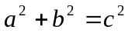.

The best-known example of a Pythagorean triple is the set 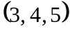 which satisfies 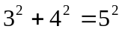

  - The following table consists of sets of Pythagorean triples which follow a particular pattern. Fill in the gaps in the table and continue the pattern for three more rows:
(3 marks)
 | a | b | c
1 | 3 | 4 | 5
2 |  | 12 | 13
3 | 7 | 24
4 | 9 |  | 41
5
6
7

  - State the equation which connects b and c in the table.
(1 mark)

  - State a rule for the value of a in the n^{th} Pythagorean triple of this type.
(1 marks)

  - Determine rules for values of b and c in the n^{th} Pythagorean triple of this type.
(2 marks)

  - Use your calculator to help you to demonstrate clearly that, in the n^{th} row,
(3 marks)

Question 3:
Listed below are the first twelve terms of the Fibonacci sequence:
1, 1, 2, 3, 5, 8, 13, 21, 34, 55, 89, 144

Using subscript notation we can rewrite this sequence as:
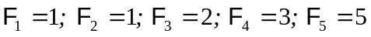 etc

  - Investigate the following pattern. Complete as many rows as necessary to determine a link between each result and a pair of terms in the Fibonacci sequence. At least four results should be calculated.
(4 marks)

Sum of squares of successive terms in the Fibonacci sequence | Result
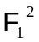 | 1
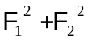
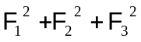
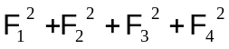

  - WITHOUT calculating a numerical answer, determine an expression for:
    - 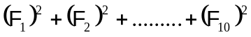
(2 marks)

    - 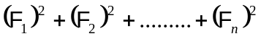, where n is any positive integer.
(2 marks)

Investigate this further pattern involving the squares of terms of the Fibonacci sequence. Again, at least four results should be calculated.
(4 marks)

Sum of squares of consecutive pairs of terms in the Fibonacci sequence | Result
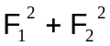 | 2
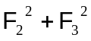
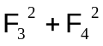

  - Determine an expression for 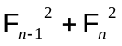
(2 marks)
Solutions:
(4 + 1 + 3 + 2 = 10 marks)
1.
Mark | Description
4 | ✓✓✓✓  (1 mark for the first four lines, 1 mark each for the last three lines.)
  1² = 1 |  | 0²+ 0 + 1 = 1
  2² = 4 |  | 1²+ 1 + 2 = 4
  3² = 9 |  | 2²+ 2 + 3 = 9
  4² = 16 |  | 3²+ 3 + 4 = 16
  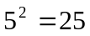 |  | 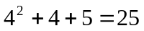
  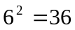 |  | 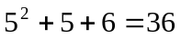
  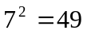 |  | 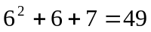

Mark | Description
1 | (b) Both columns give the same results. ✓

Mark | Description
3 | (c) 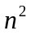 ✓ and 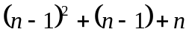 ✓✓

Mark | Description
2 | (d) = 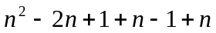 ✓  = 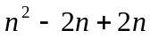  = ✓  Both expressions simplify to .

(3 + 1 + 1 + 2 + 3 = 10 marks)
2
Mark | Description
3 | ✓✓✓ (1 mark each for the columns headed a, b and c)
   | a | b | c
  1 | 3 | 4 | 5
  2 | 5 | 12 | 13
  3 | 7 | 24 | 25
  4 | 9 | 40 | 41
  5 | 11 | 60 | 61
  6 | 13 | 84 | 85
  7 | 15 | 112 | 113

Mark | Description
1 | (b) 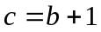 ✓ (Or 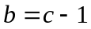)

Mark | Description
1 | (c) n^{th} value of a = 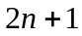 ✓

Mark | Description
2 | (d) n^{th} value of b = 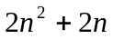 ✓ (Or 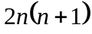)  n^{th} value of c = 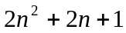 ✓

Mark | Description
3 | (e) 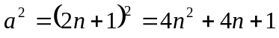  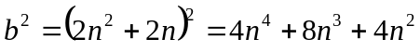 ✓  ✓  ✓  Hence result.

(4 +4 + 4 + 2 = 14 marks)
3
Mark | Description
4 | (✓✓✓✓ One mark for each of four correctly calculated results. If, in addition, there are other results which are not correctly calculated, deduct 1 mark.)
  Sum of squares of successive terms in the Fibonacci sequence | Result
   | 1
   | 2
   | 6
   | 15
  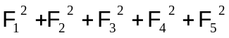 | 40
  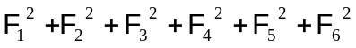 | 104

Mark | Description
4 | (b) (i) 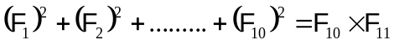 ✓✓  (ii) 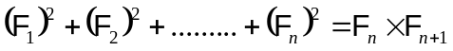✓✓

Mark | Description
4 | (✓✓✓✓ One mark for each of four correctly calculated results. If, in addition, there are other results which are not correctly calculated, deduct 1 mark.)
  Sum of squares of consecutive pairs of terms in the Fibonacci sequence | Result
   | 2
   | 5
   | 13
  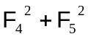 | 34
  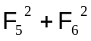 | 89
  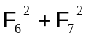 | 144
  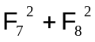 | 233

Mark | Description
2 | (d)  

